**CS450 Programming Assignment 4 Test Case**

**Andrew Patterson and Changyu Wu**

**Group 27**

**Test Cases**

**Test Case 1:**

This test case simply creates a regular file in the root directory and then creates a small file at the same place, as a comparison. There should be no problem creating a regular file but a fault should be raised when creating a small file, as the root directory is a regular directory:

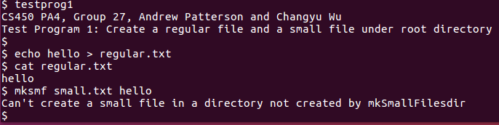

**Test Case 2:**

This test case creates a regular directory and then create a regular file as well as a small file inside of it. There should be no problem creating a regular file but a fault should be raised when creating a small file, as the directory is not created by **mkSmallFilesdir**:

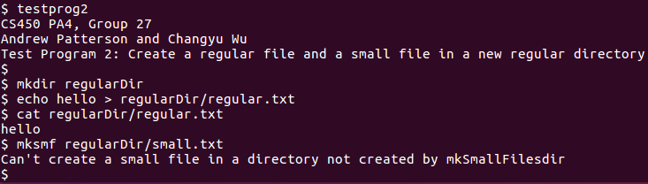

**Test Case 3:**

This test case creates a small directory using **mkSmallFilesdir** and then create a small file as well as a regular file inside of it. There should be no problem creating a small file but a fault should be raised when creating a regular file, as the directory is not a regular directory:

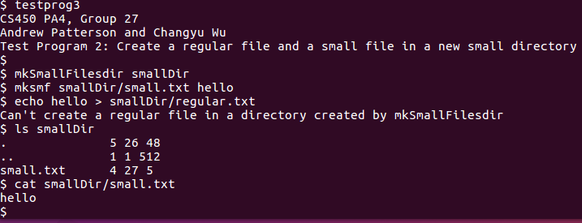

**Test Case 4:**

This test case tries to link a regular file to a small file, a small file to a regular file, a regular file to a regular file and a small file to a small file. The first two cases should fail but the latter two should succeed:

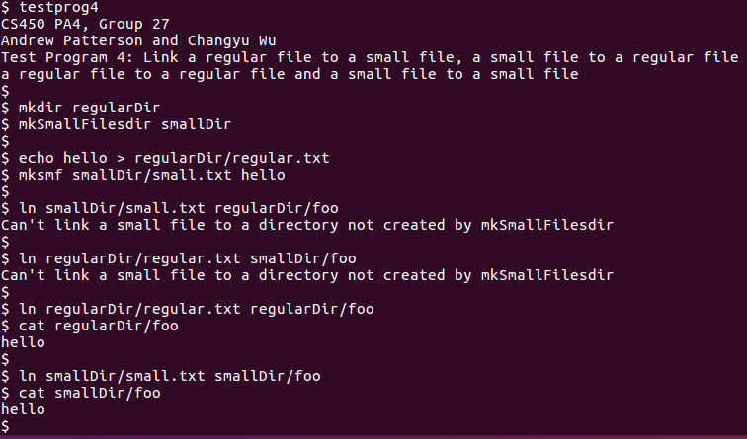

**Test Case 5:**

This test case creates a small directory and stores two small files into it, one has 52 bytes and the other one has 53 bytes, which tries to exceed the maximum byte limit while writing to the file, the second file will be created but nothing will be written to it:

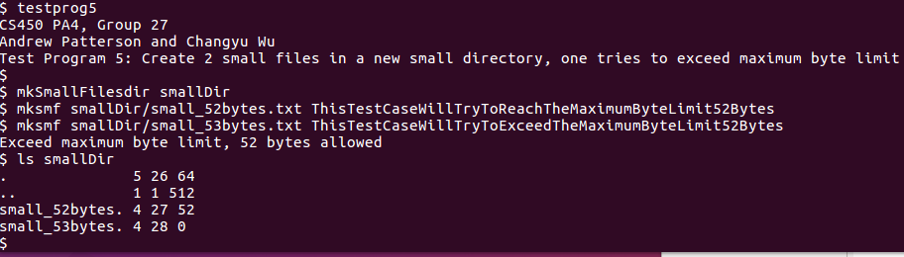

**More Test Cases:**

You can use **mkSmallFilesdir**  and **mksmf** commands to do some random test cases as you wish, usage can be found in **README** file